Jack Ballman

ME 1020 Final Project

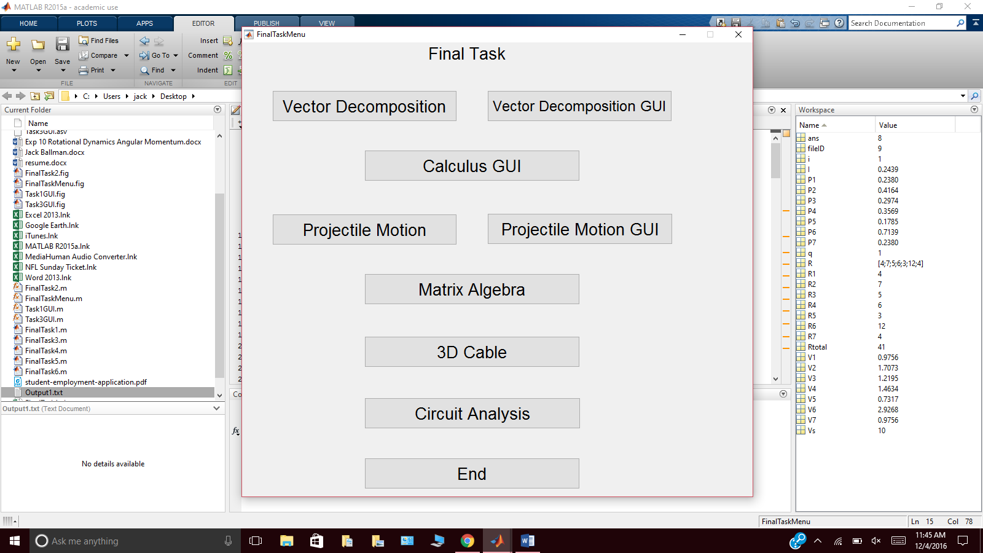

ME 1020-01

Dennis Hance

December 6th, 2016

**Introduction**

This purpose of this project was for students to demonstrate the skills that they have learned throughout this course by performing a number of tasks, including GUI’s and test-based problems. In this report, I will go into detail about the various tasks that were assigned as part of this project as well as explain how I went about completing them. These tasks include a vector decomposition program, a calculus-solving program, a projectile motion simulator, a matrix algebra solver, a 3D-cable program and a circuit analysis solver.

**Overview**

My main goal when working through this project when it was assigned to us was to complete 2 tasks per week. I started this project by first doing what I could to complete the necessary GUI’s required for this project. After I was finished creating those, my next goal was to write the code needed to perform all of the necessary calculations. I worked through typing the code for each task, in order before I proceeded to writing the results to Excel and text files. The last thing that I did to finish this project was finish writing all of the code for each task, adding the necessary code to write the results to Excel and text files.

**Task 1: Vector Decomposition**

The first thing that I did for this program was create the GUI. Once that was done, I went and created the TUI version of this program, and then added the code into the GUI. Because the requirement was to allow to the program to run up to 15 times, I used a ‘for’ loop with an input dialogue box to collect the data for the magnitude and angle of each vector inside of the loop, and then I calculated the resultant angle and magnitude outside of the loop and the plotted all of the given vectors and the resultant. For the GUI, the START button finds whatever number you entered into the box and brings up the input dialogues for however many vectors you entered. The start button also puts the results into separate boxes, plots the vectors and writes the results to excel. The ‘Clear’ button sets all of your values back to 0, so you can re-run the program. The ‘Clear Plot’ button resets the plot so it is blank. The ‘Close’ button ends the program and brings up the Start Menu.

Code preview:

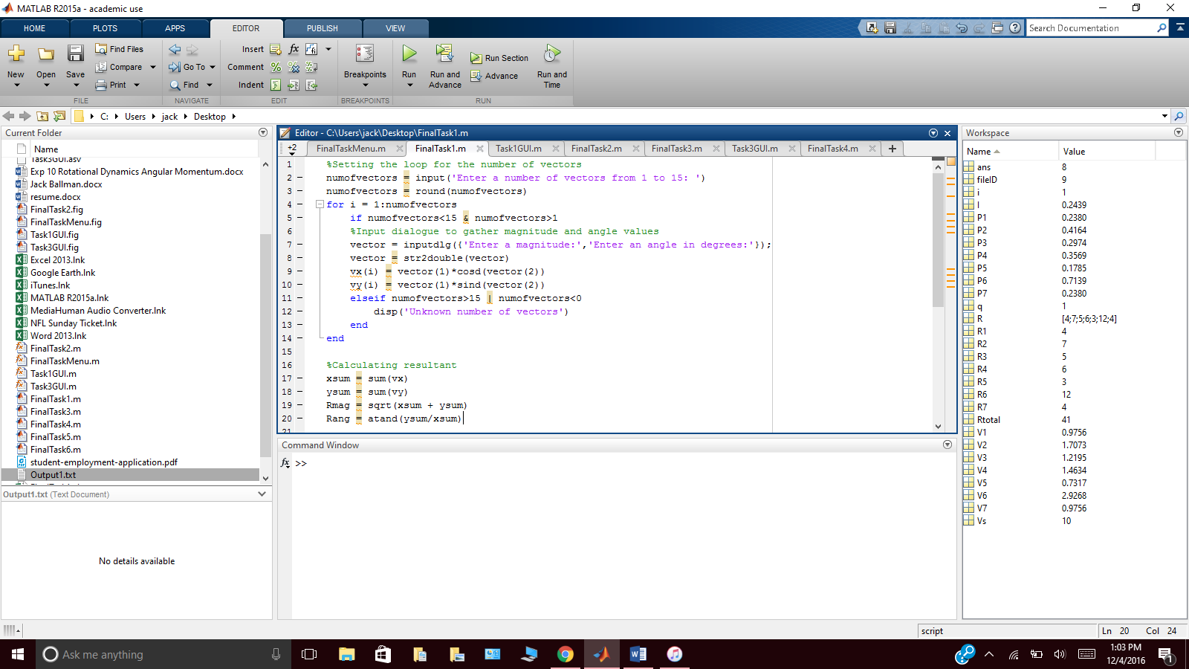

**Task 2: Calculus Solver**

For this program, we were required to create either a GUI version or a TUI version. I decided to do the GUI version. Once I had all of the boxes and button in the GUI, I added all of the code into it. Because the task requires certain variables to remain in the equation, I used the symbolic method to leave ‘X’ in the results. After I was done adding all of the code for the calculations into the various buttons, I added code into the ‘Close’ button to close the Calculus GUI and bring up the Start Menu. In the GUI, the ‘1st Derivative’ button takes the values from the 3 edit text boxes and finds the first derivative, with respect to X. The ‘2nd Derivative’ button does the same thing as the ‘1st Derivative’ button, but it calculates the 2nd derivative. The ‘3rd Derivative’ button does the same thing, but calculates the 3rd derivative of the inputs. The ‘Integral’ button calculates the integral of the inputs and puts the results into the separate boxes.

Code sample:

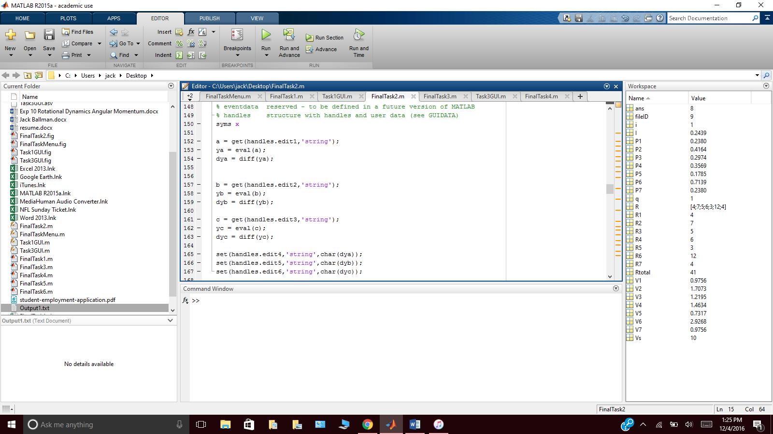

**Task 3: Projectile Motion**

For this task, we were required to create both a TUI program and a GUI program. For the TUI program, I started it with code asking for an input for the initial velocity and angle of the projectile. With those inputs, I wrote code to find the maximum height the projectile reaches, the time the projectile was in the air and the distance the projectile traveled. For the GUI, the ‘Calculate’ takes the velocity and angle inputs entered by the user into the 1st two edit text boxes and uses them to calculate the max height, time in air and distance traveled. The ‘Clear’ button sets all of the inputs and outputs back to 0. The ‘Plot’ button plots all of the calculations for the projectile. The ‘Clear Plot’ button clears the plot and makes it blank. The ‘Close’ button closes the program and opens the Start Menu. To find the height, distance and time values, I had to find the velocity in the X and Y directions using “vx=vel*cosd(angle)” and “vy=vel*sind(angle)” For the plotting, I had to use t=linspace(0,TimeInAir) to get the x-axis values for the ‘time’. For the y values, I had to use the “y=vt+0.5gt^2” equation.

Code sample:

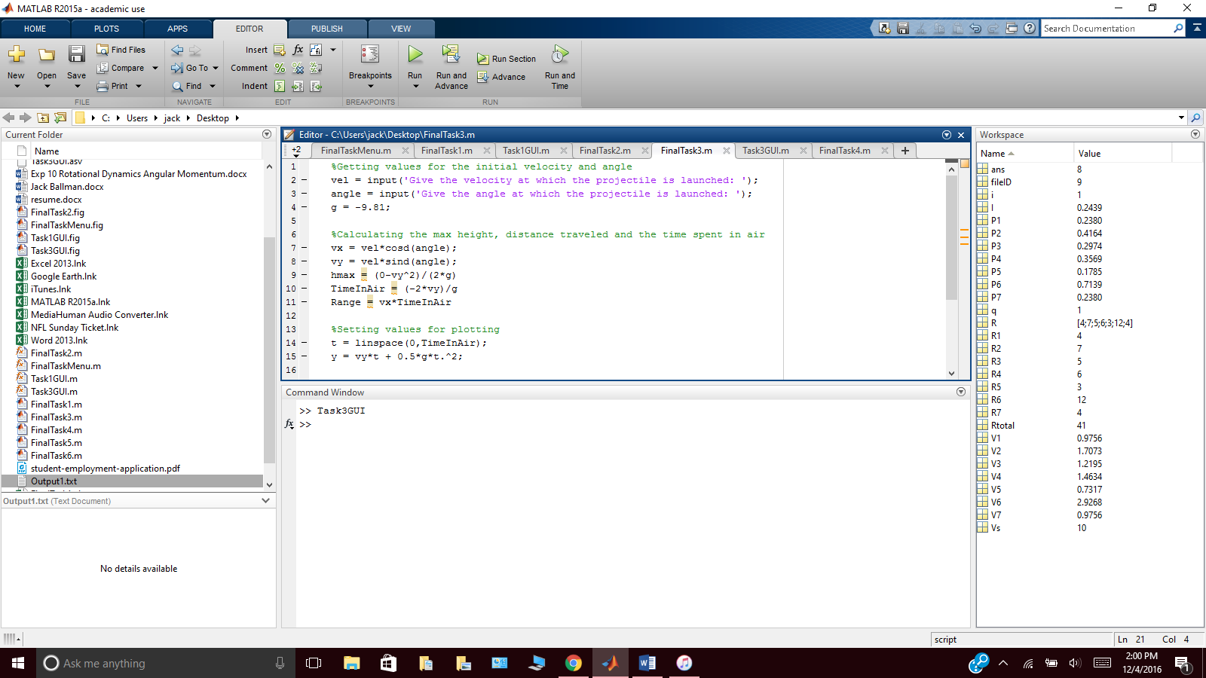

**Task 4: Matrix Solver**

For this task, we had the option to create either a text-based program or a GUI version. I opted to go with the text-based version. I used 5 if and elseif conditionals, all of which have the code for either a 2x2, 3x3, 4x4 or a 5x5 matrix. The code asks for an input of what kind of matrix you would like to run, allowing you to enter either 2x2, 3x3, 4x4, or 5x5. If one of those was not entered, I included an elseif conditional to put an error message for an unrecognized input. Every conditional had its own code for writing the results to excel, user inputs for the matrix coefficients, and symbolic values to create the equations. To add the solutions for the variables to excel, I had to use the “char” command so they would show up the right way. There is code at the very end of the script to bring up the Start Menu when the code is finished running.

Code sample:

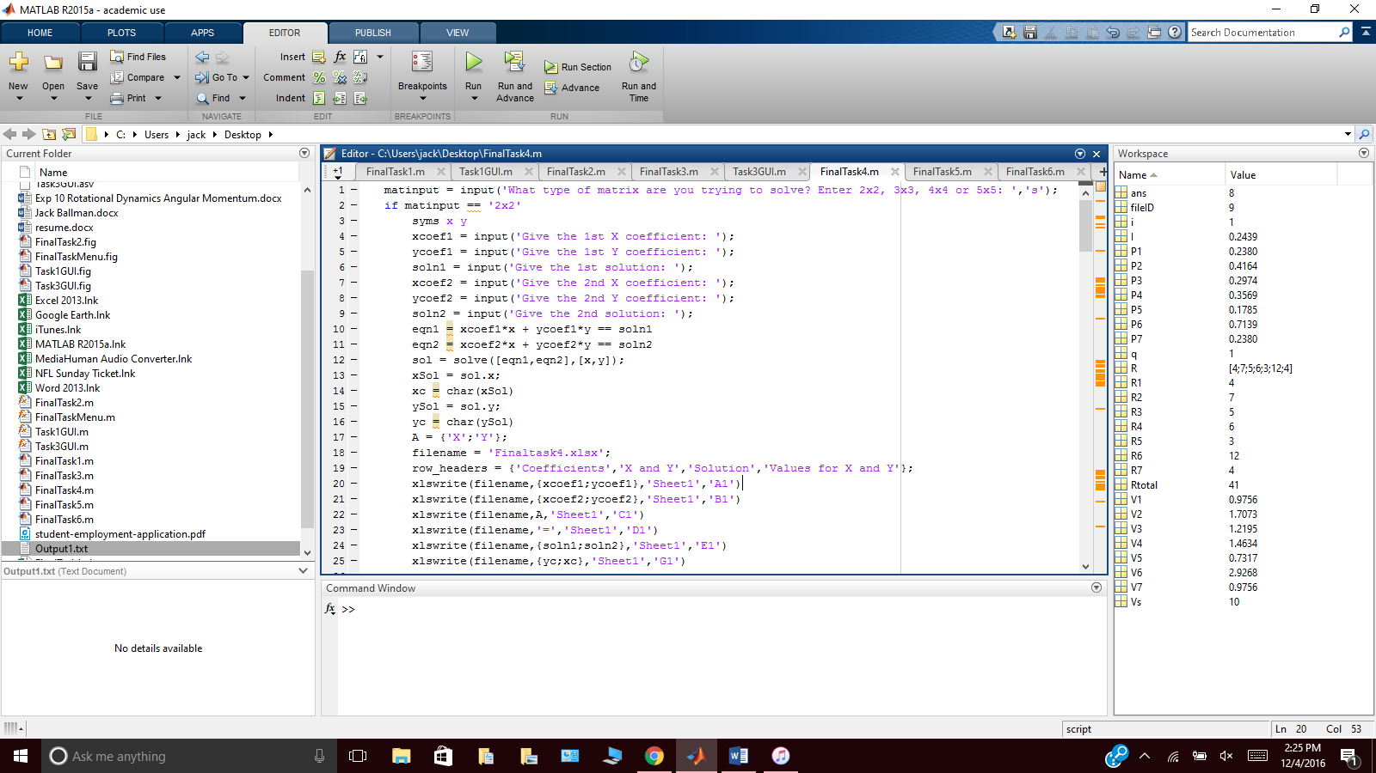

**Task 5: 3D Cable**

For this task, we were required to create a test-based solution. The first thing that I did for this program was put in a ‘for’ loop for the user to input how many times the program should be ran. I then have inputs for TensionA, TensionB, TensionC, coordinates for A, coordinates for B, coordinates for C, and the coordinates for the balloon. I then used all of those user-inputs to calculate the magnitudes and Fx, Fy, and Fz values for all of the separate cables and their tensions. I then used those values to calculate the magnitude of the resultant vector and the angle of the resultant vector. For the writing to Excel, I used the calculated vales for the magnitude of the resultant vector and the angle of the resultant vector.

Sample code:

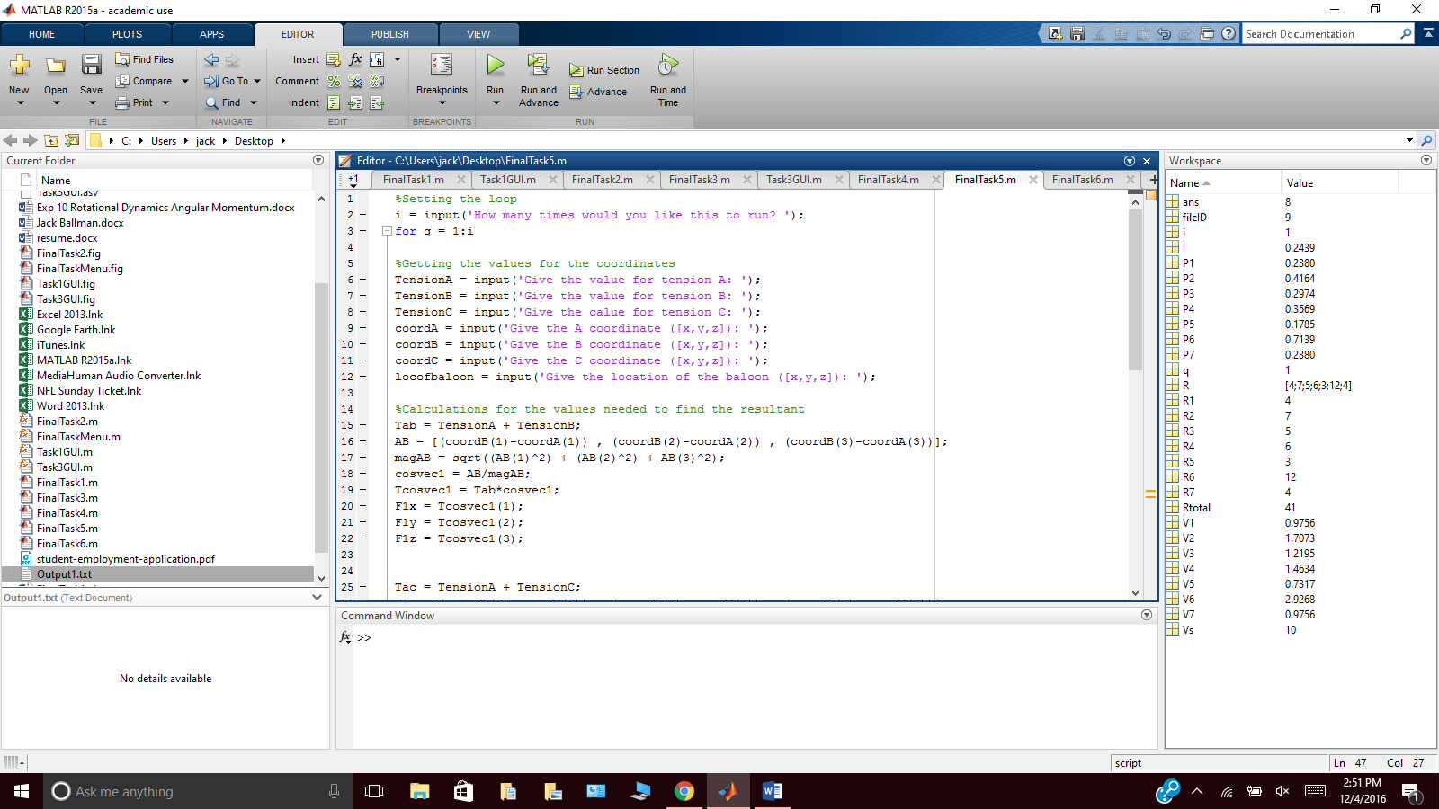

**Task 6: Circuit Analysis**

For this task, the first thing that I did was put in a ‘for’ loop to designate how many times the program should run. Inside of that loop, I put in 8 user-inputs to collect the values for the source voltage and the values for each resistor. Under each of those inputs, I put separate ‘if’ conditionals to display an error message if an out of range or unrecognized input is entered. After all of those values are collected, I put in code to calculate the total resistor value, the voltage drop across each resistor, the power across each resistor, and the total current, the current across each resistor and the total power in the circuit. The last part of the program is code that will write all of the results to a text file called ‘Output1.txt’.

Sample code:

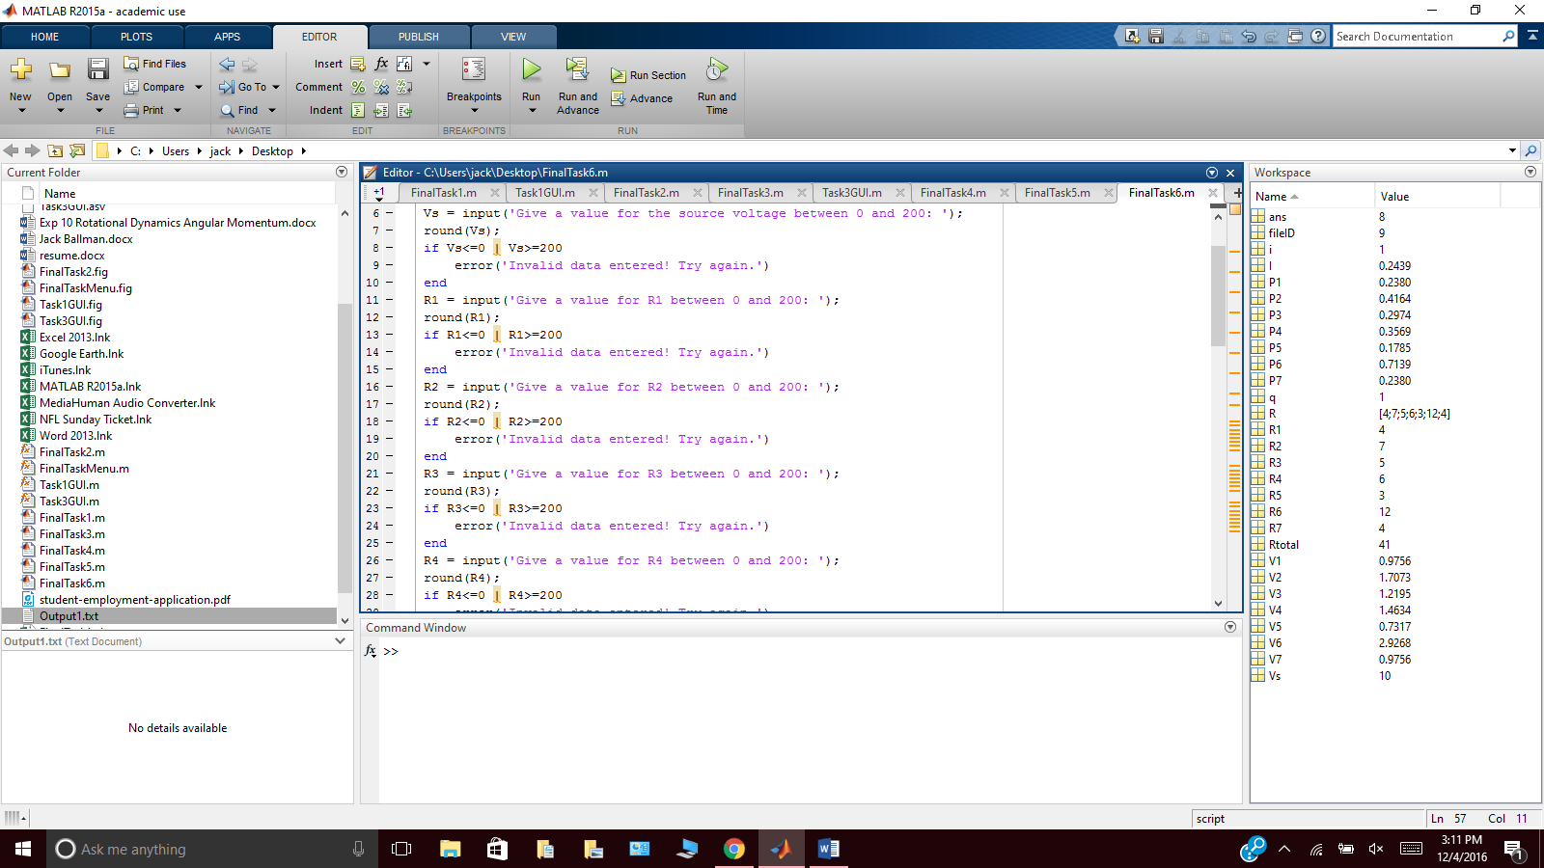

**Problems Encountered and Solutions**

For Task 1, I was having trouble figuring out how to get all of the values for the possible 15 vectors without having hundreds of lines of code, but then I learned how to use the input dialogue boxes. I was also having trouble with the column headers when writing to Excel, but I did some research and figured that out.

For Task 2, I was trying to figure out why my results weren’t coming out the way that they should be and why I was getting errors, but then I realized that I wasn’t using any form of symbolic variables in my code, but after I put ‘syms x’ everything started working out fine.

For Task 3, my plot wasn’t coming out right at all, but then I realized that I had to use the linspace(0,TimeInAir) for the time values on the x axis and y=vt+0.5gt^2 for the values on the y axis.

For Task 4, one of the problems that I had was the same as the problem I had for Task 2, where I just forgot to write ‘syms x’ on beginning of the script. Another problem that I encountered in this task was trying to write all of the data to Excel. I was trying to do it all in a few lines but since it wasn’t working for me, I decided that I had to go in and put individual xlswrite commands for each matrix option in each of the conditionals.

For Task 5, I was having trouble with finding the resultant vector and angle. I didn’t realize I needed to calculate the values for the cosine vectors, but after I learned that, I found all of the sums and values that I needed to calculate the resultant.

For Task 6, I was trying to figure out how to find the power dissipation in each resistor, but after some research I found the correct equation.

**Conclusions**

In this project, I learned about the usefulness of MATLAB. When I first saw this assignment, I thought the GUIs that we were required to create would be extremely difficult. However, the GUI’s became something that I almost enjoyed doing. I realized how much more useful and user-friendly they are than the text-based programs. While in the process of doing this assignment, I also saw the many uses that MATLAB can have. I found myself using MATLAB for some of my other classes just because it made finding multiple different calculations so much easier.

Another thing that I learned from completing this project was the importance of user-friendliness and attention to detail. While going through this project, I found that doing things like suppressing unnecessary data, adding as many features as I could into my GUI’s, making my Start Menu and other GUI’s as organized as I could and adding input dialogue boxes into longer scripts of data made the project look and function much better.

**Appendices**

**Task 1**

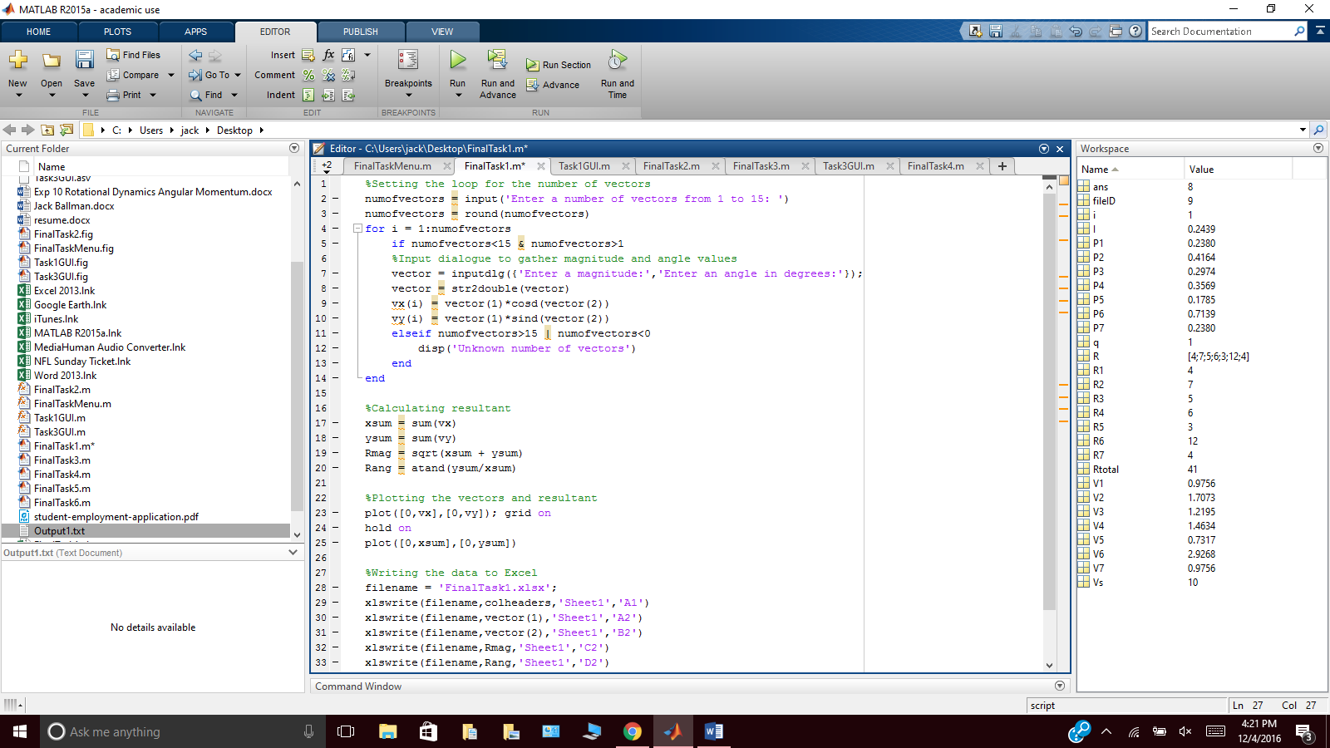

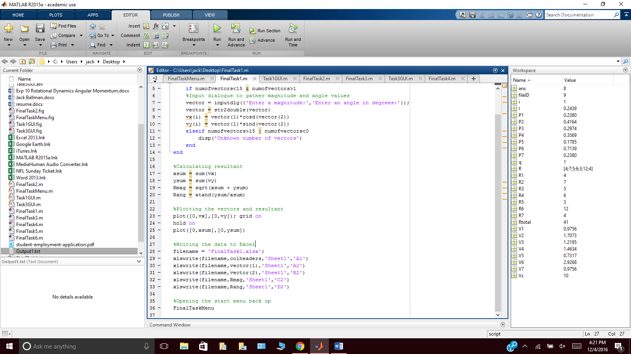

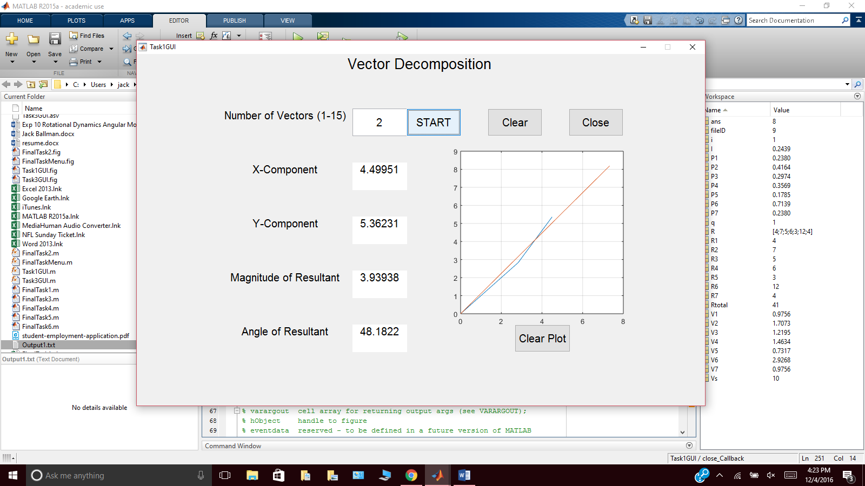

**Task 2**

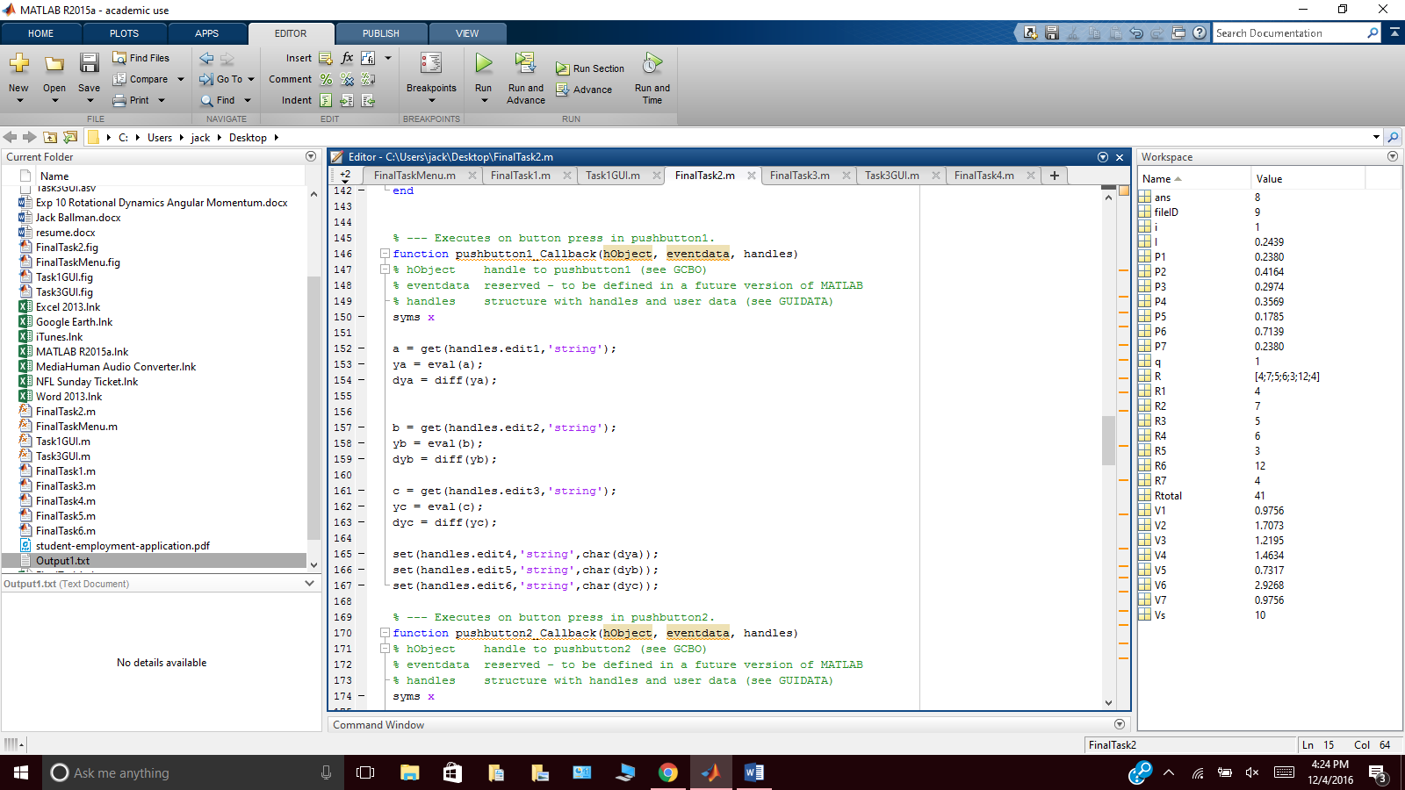

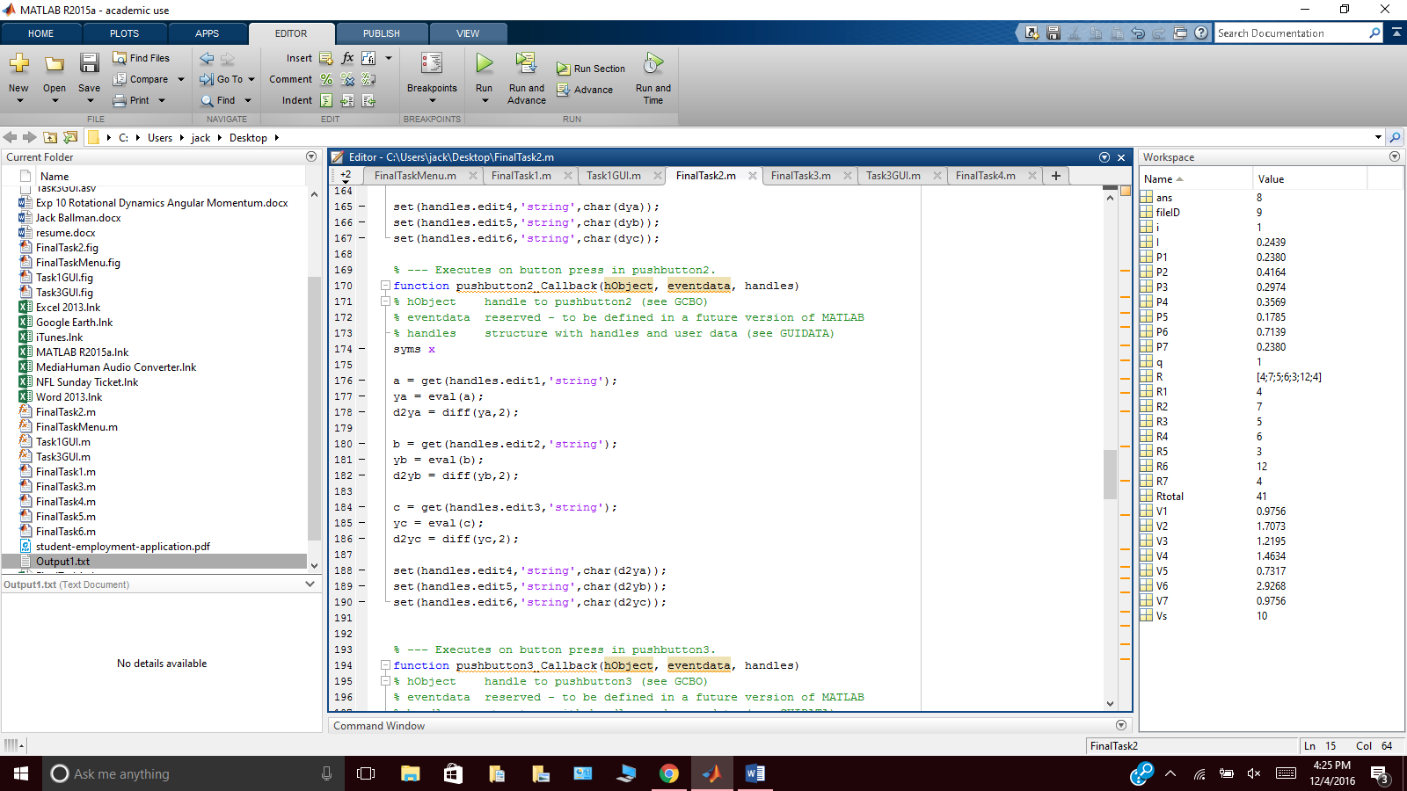

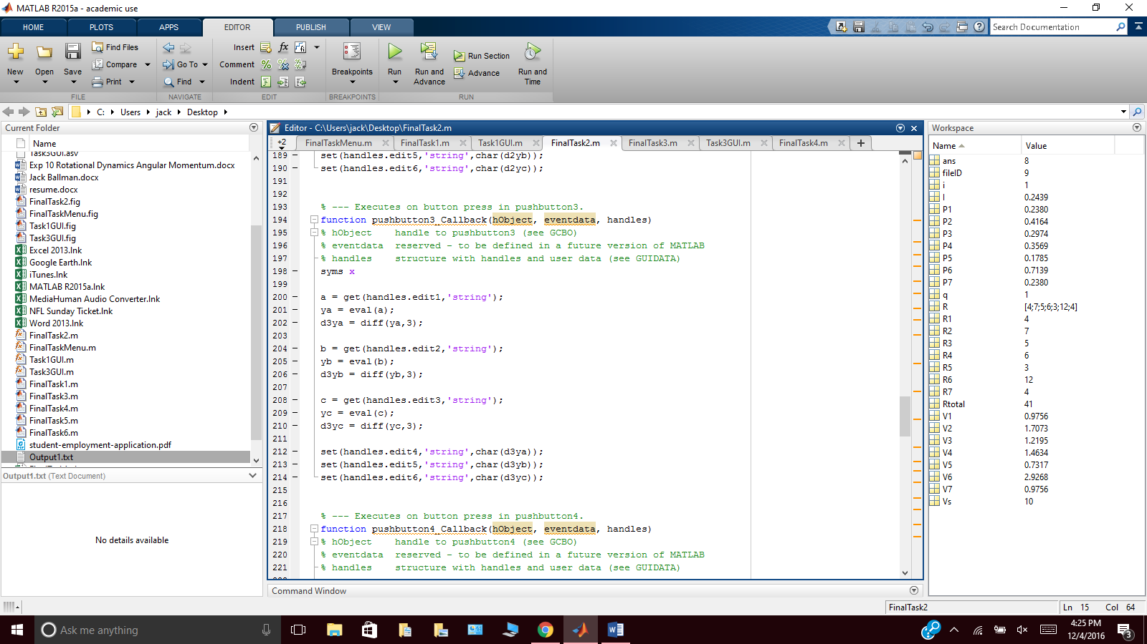

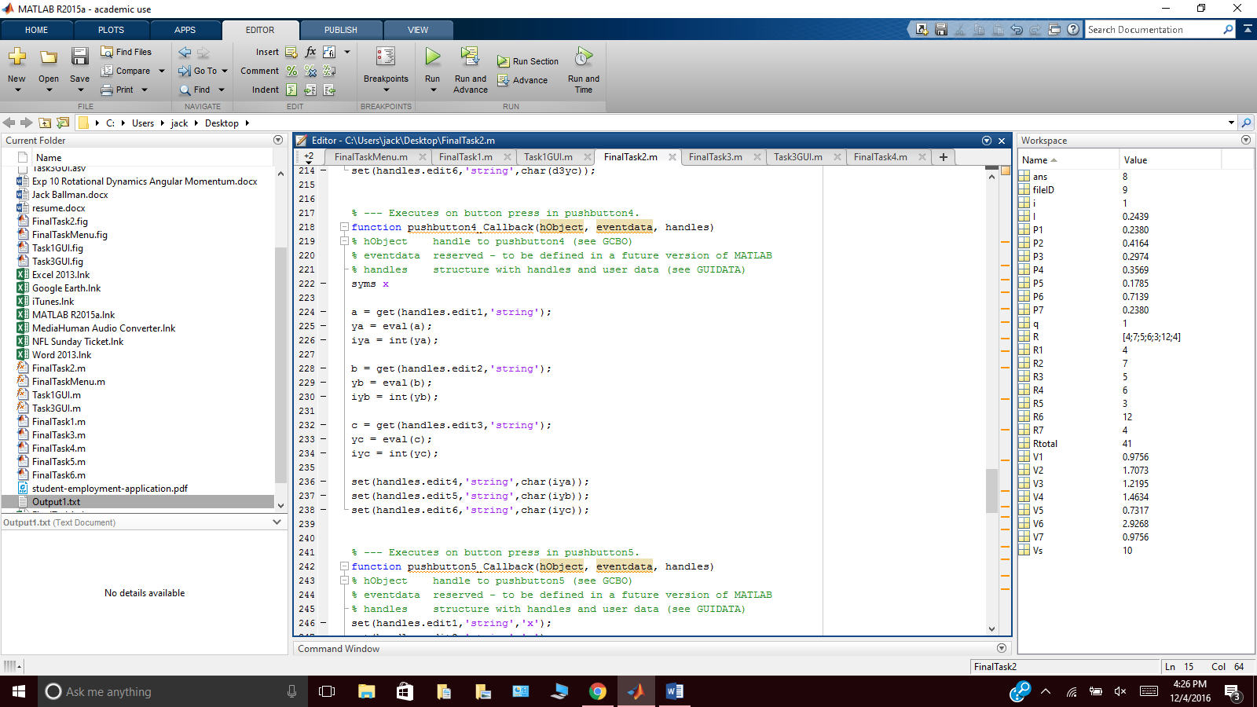

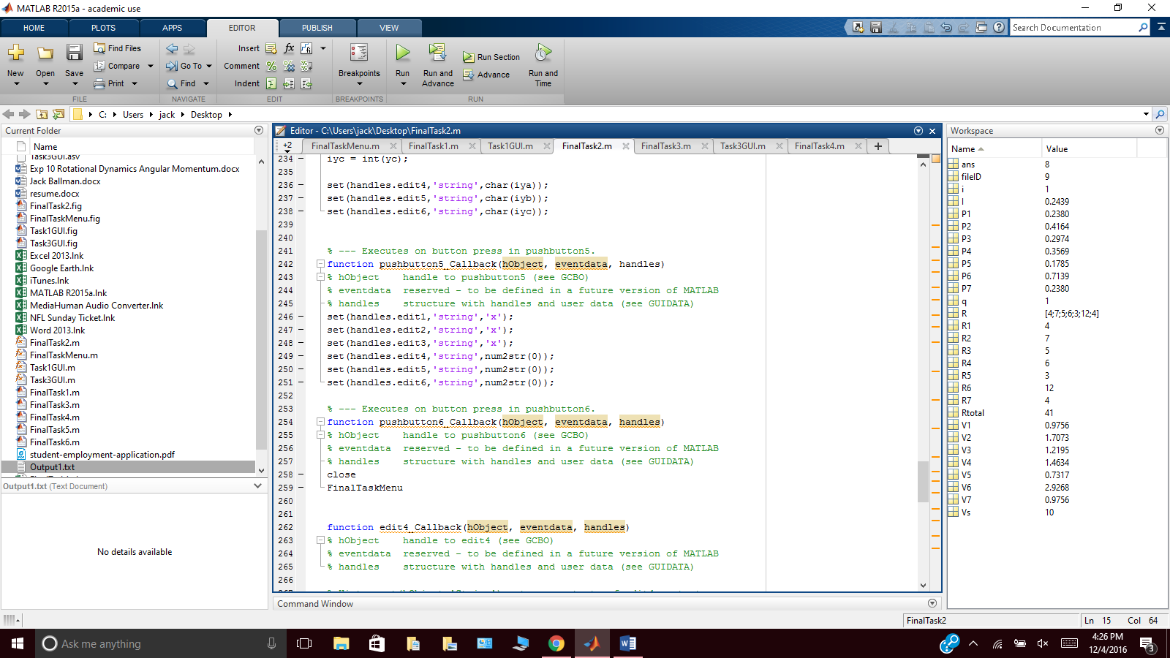

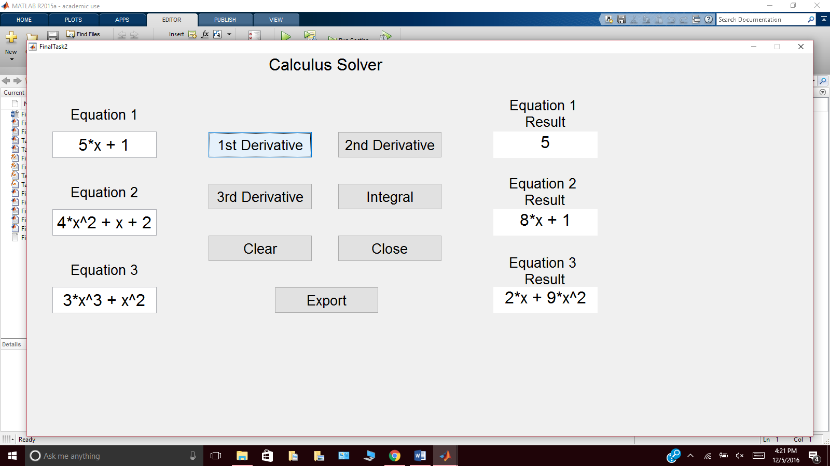

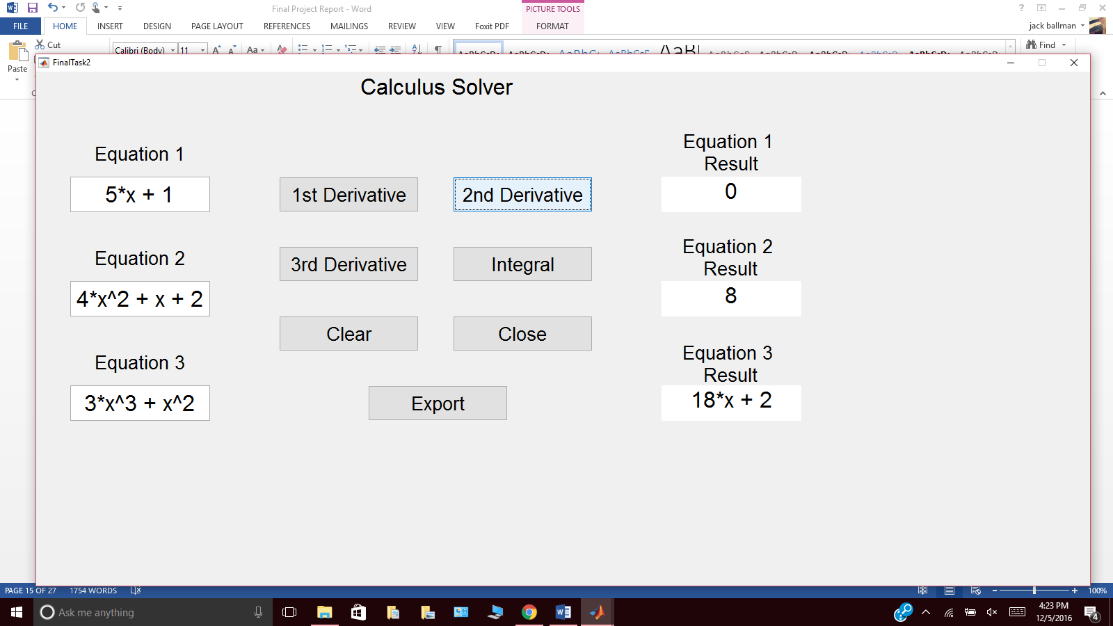

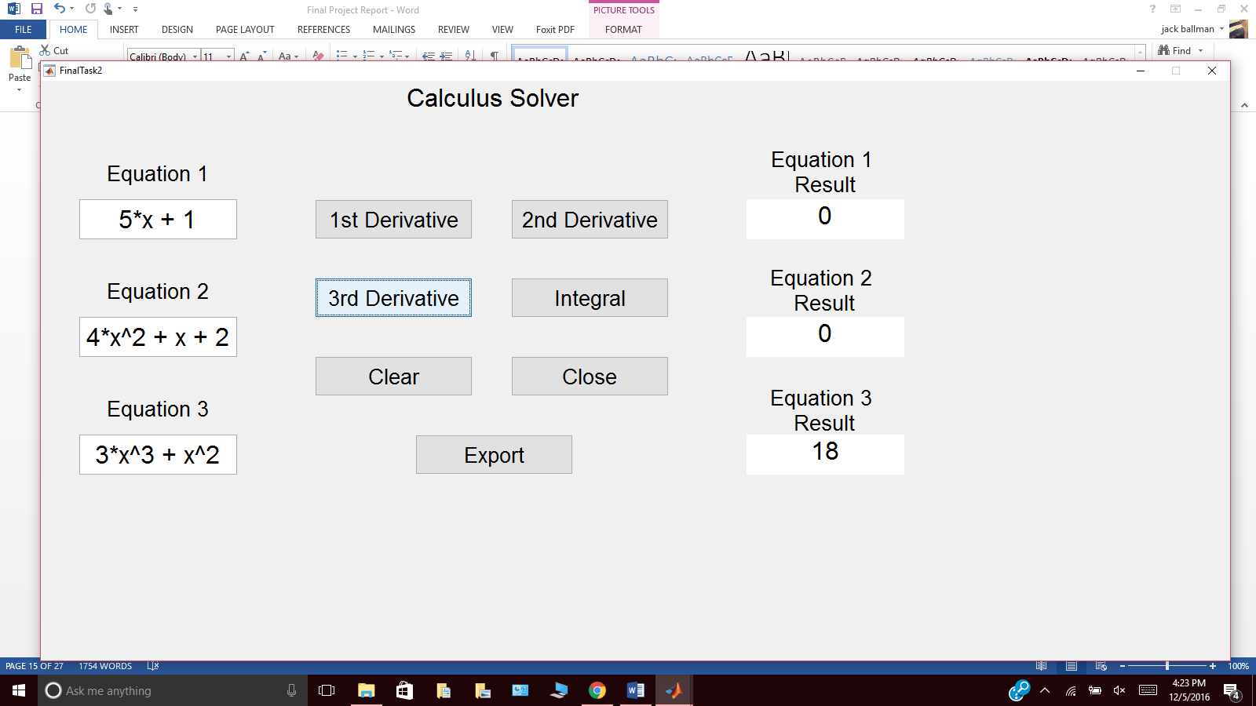

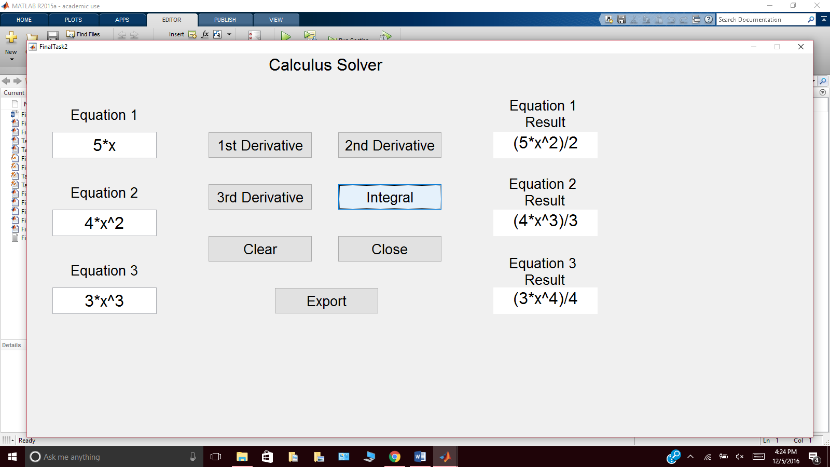

**Task 3**

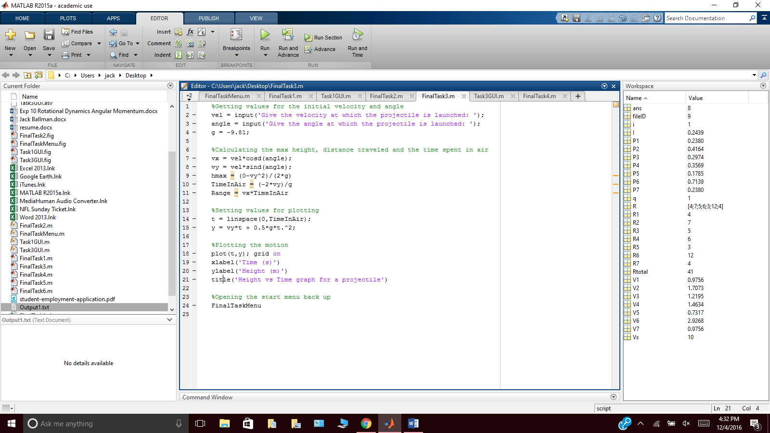

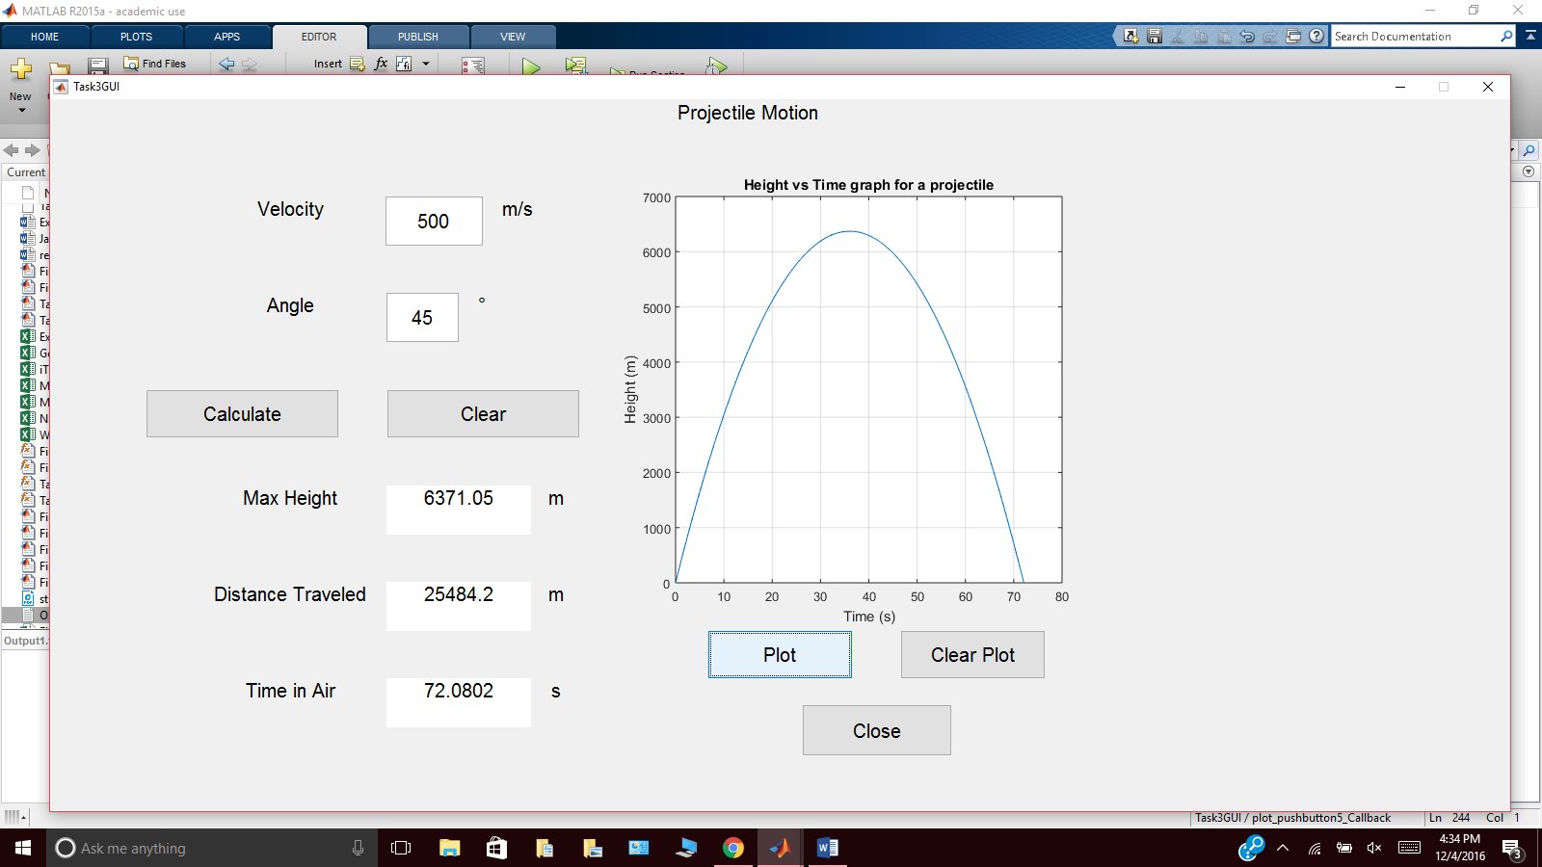

**Task 4**

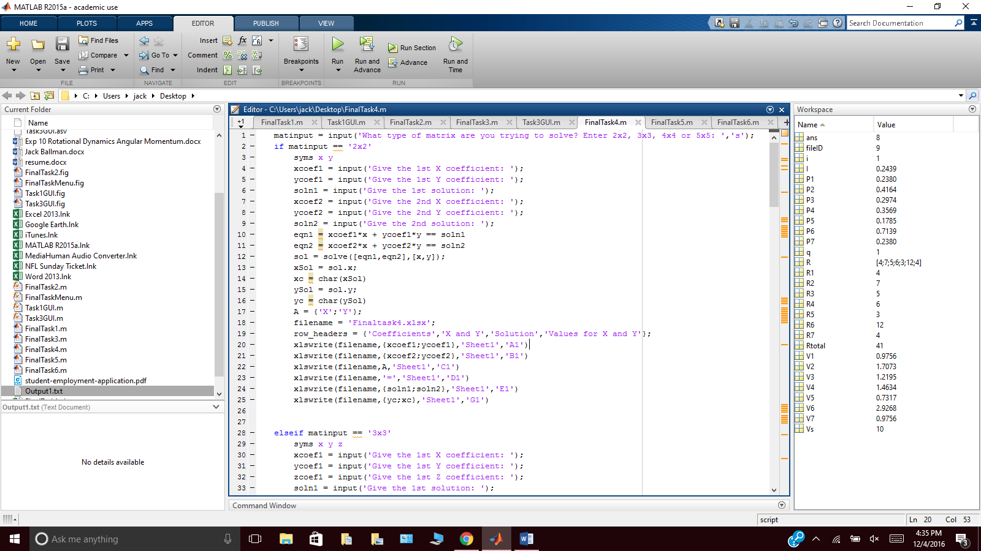

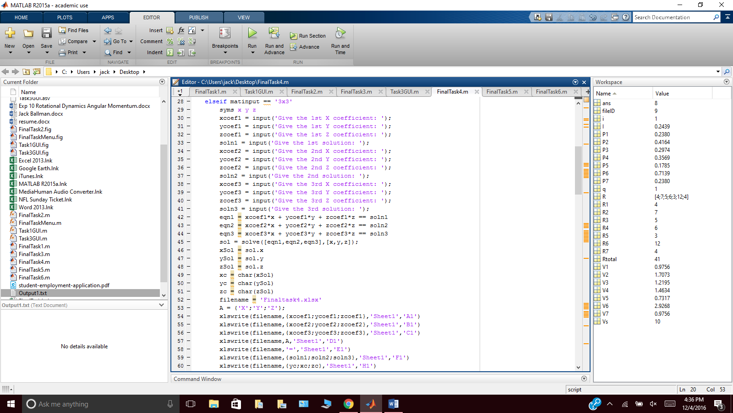

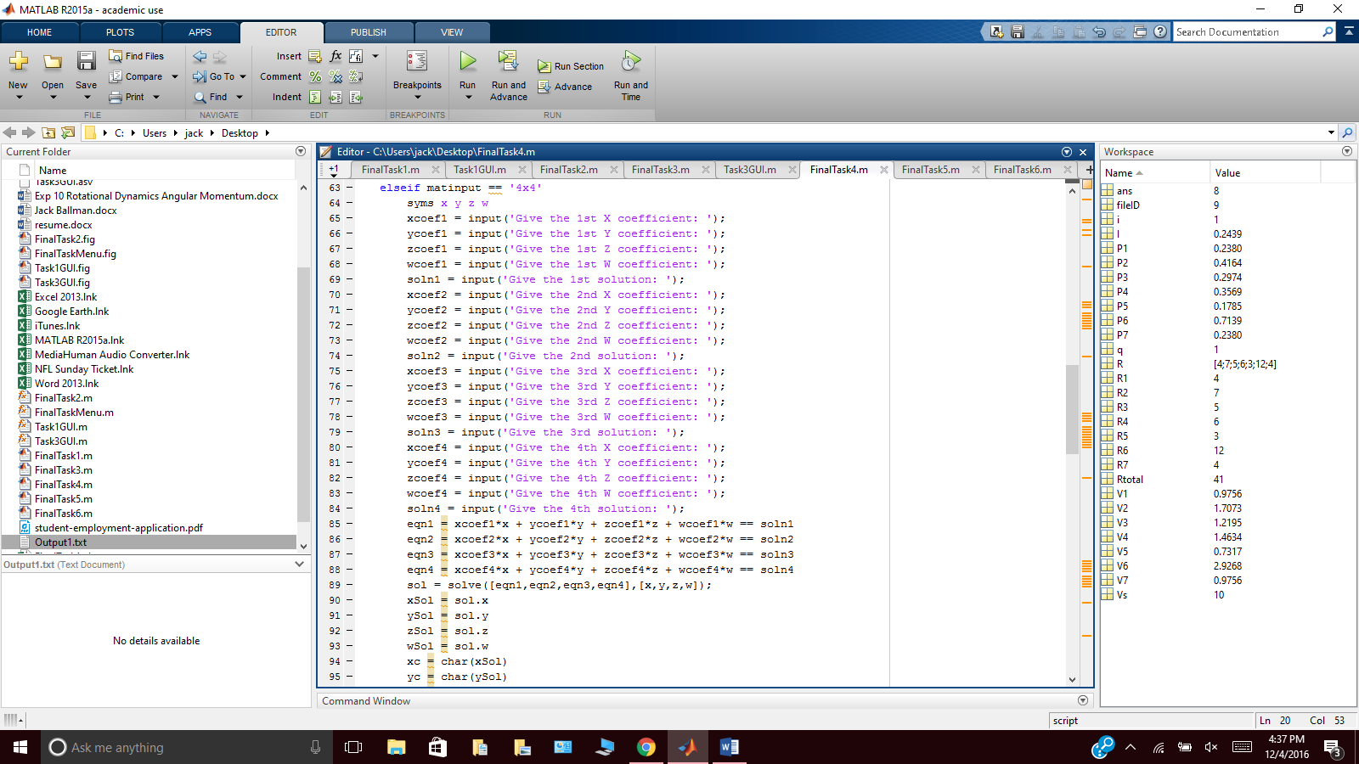

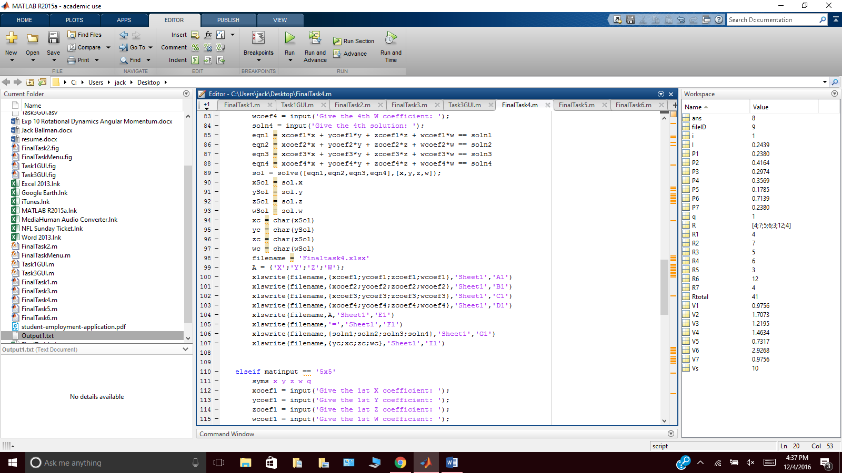

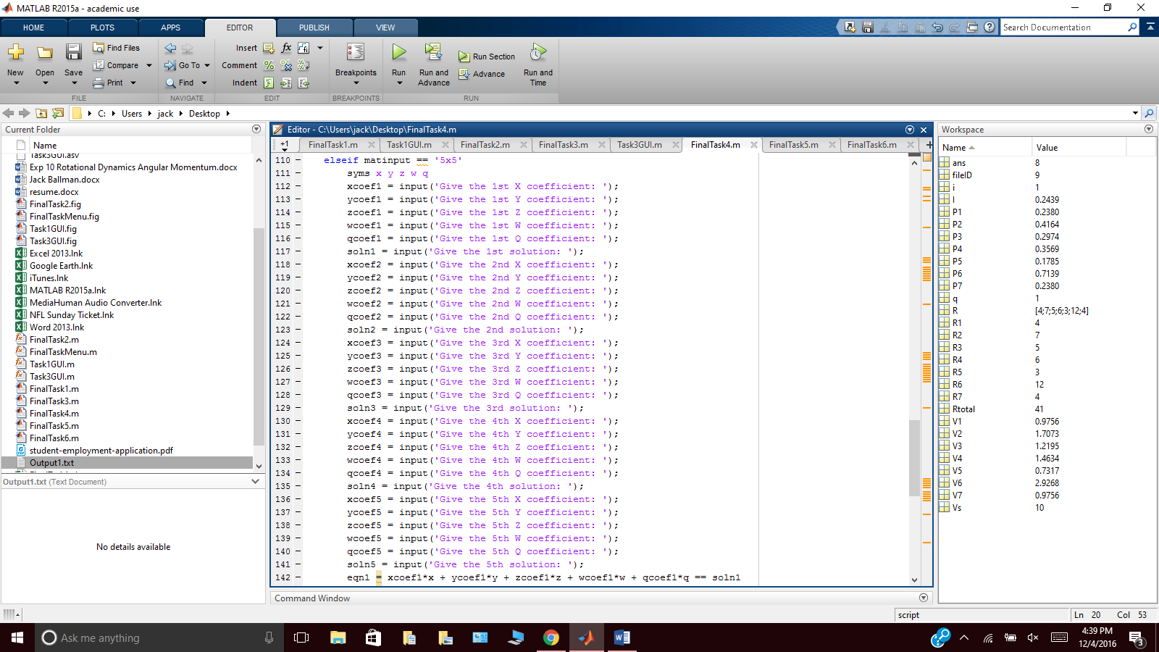

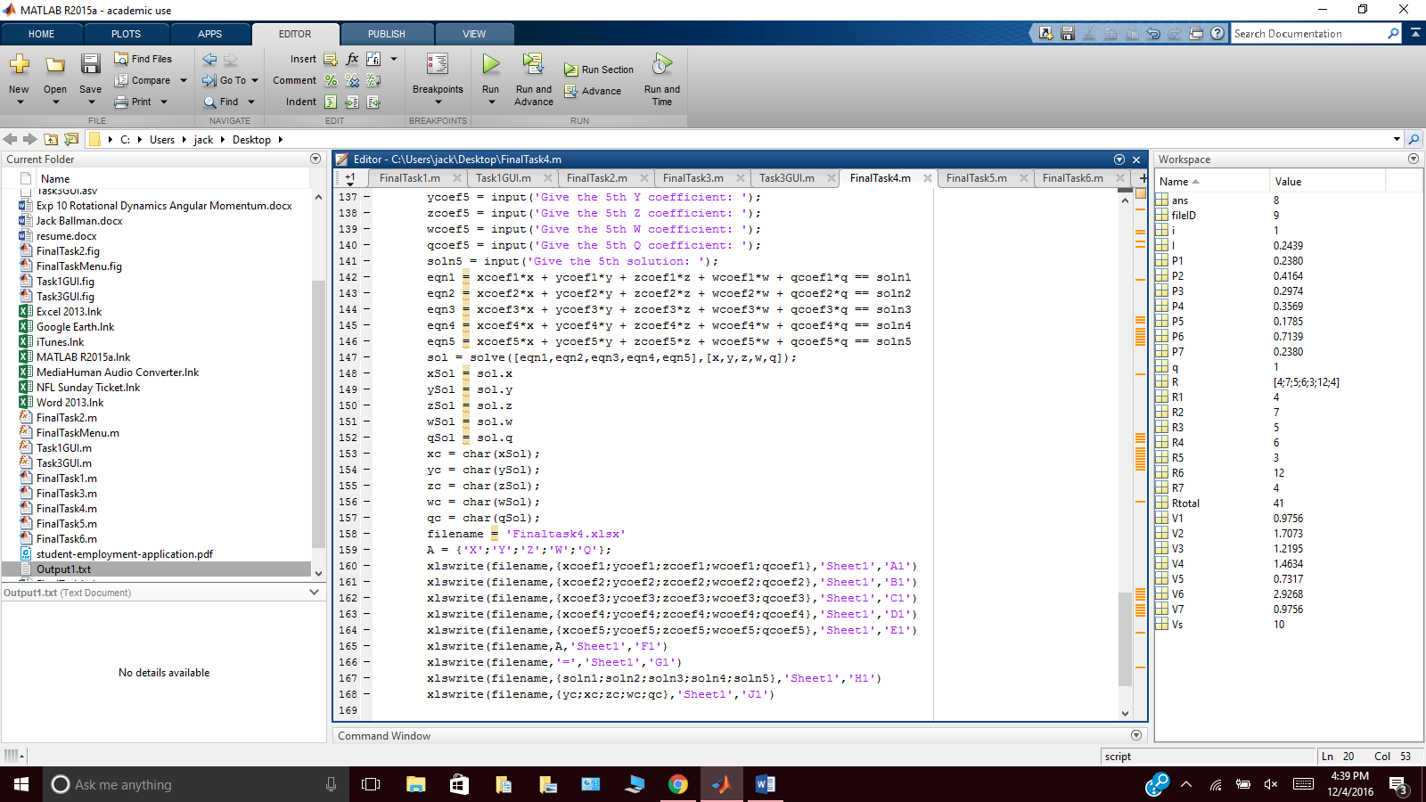

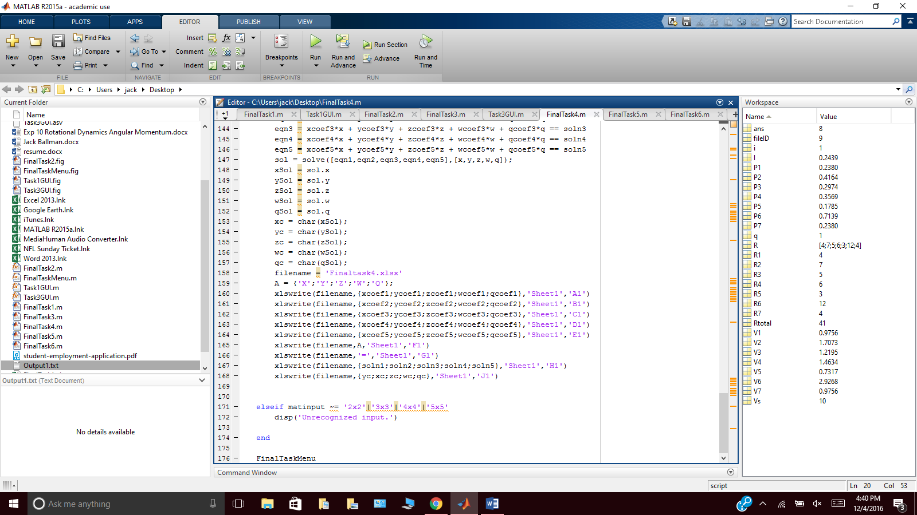

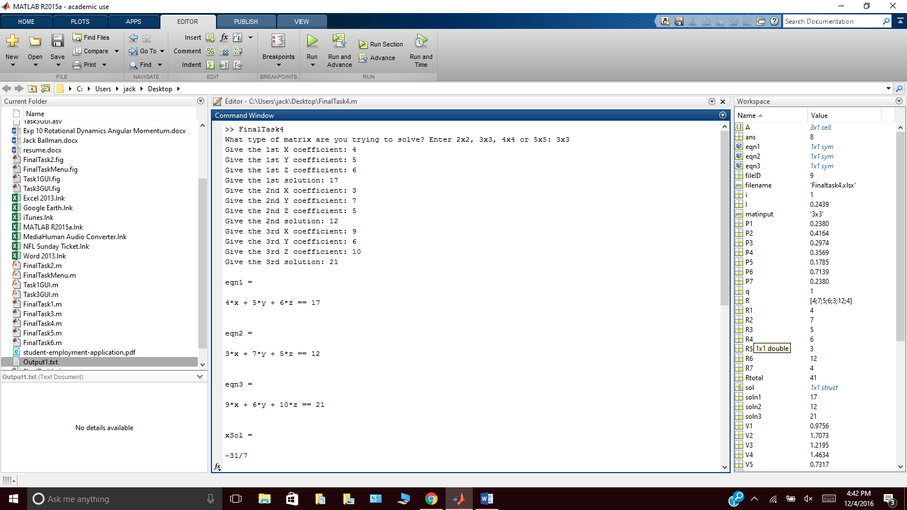

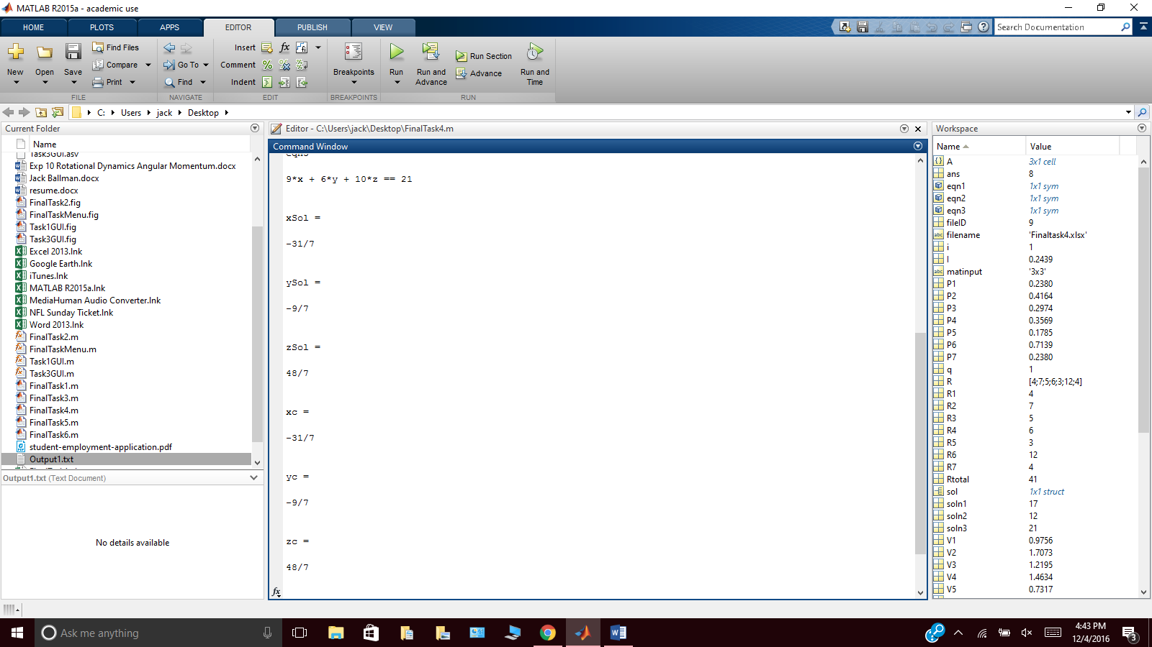

**Task 5**

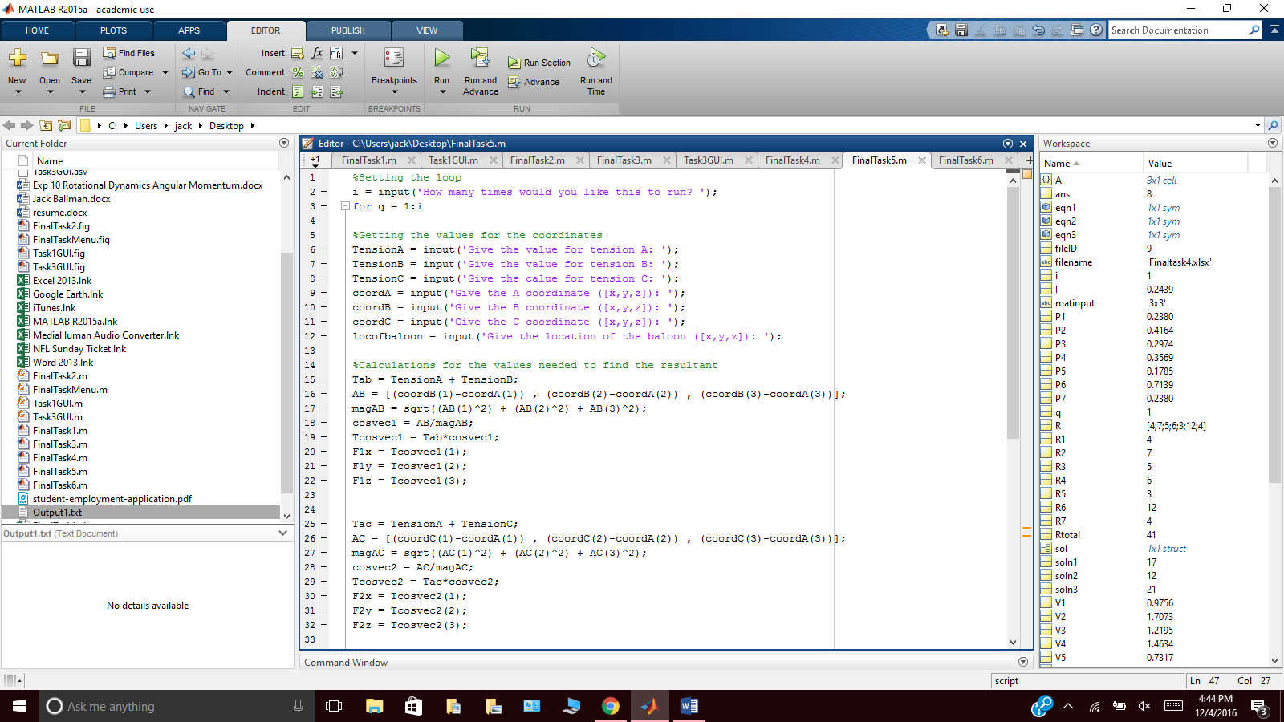

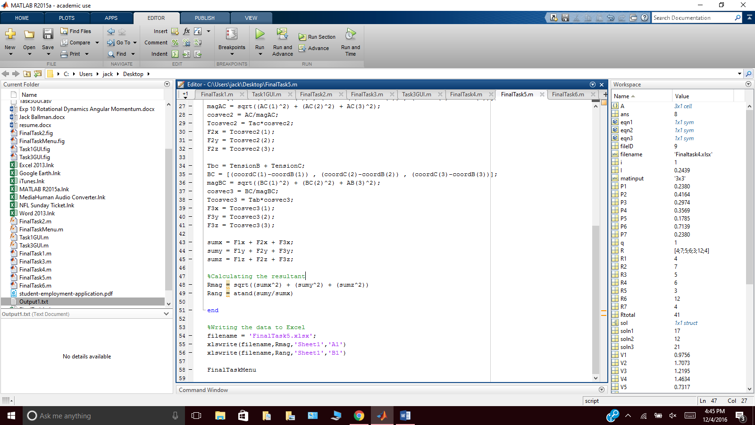

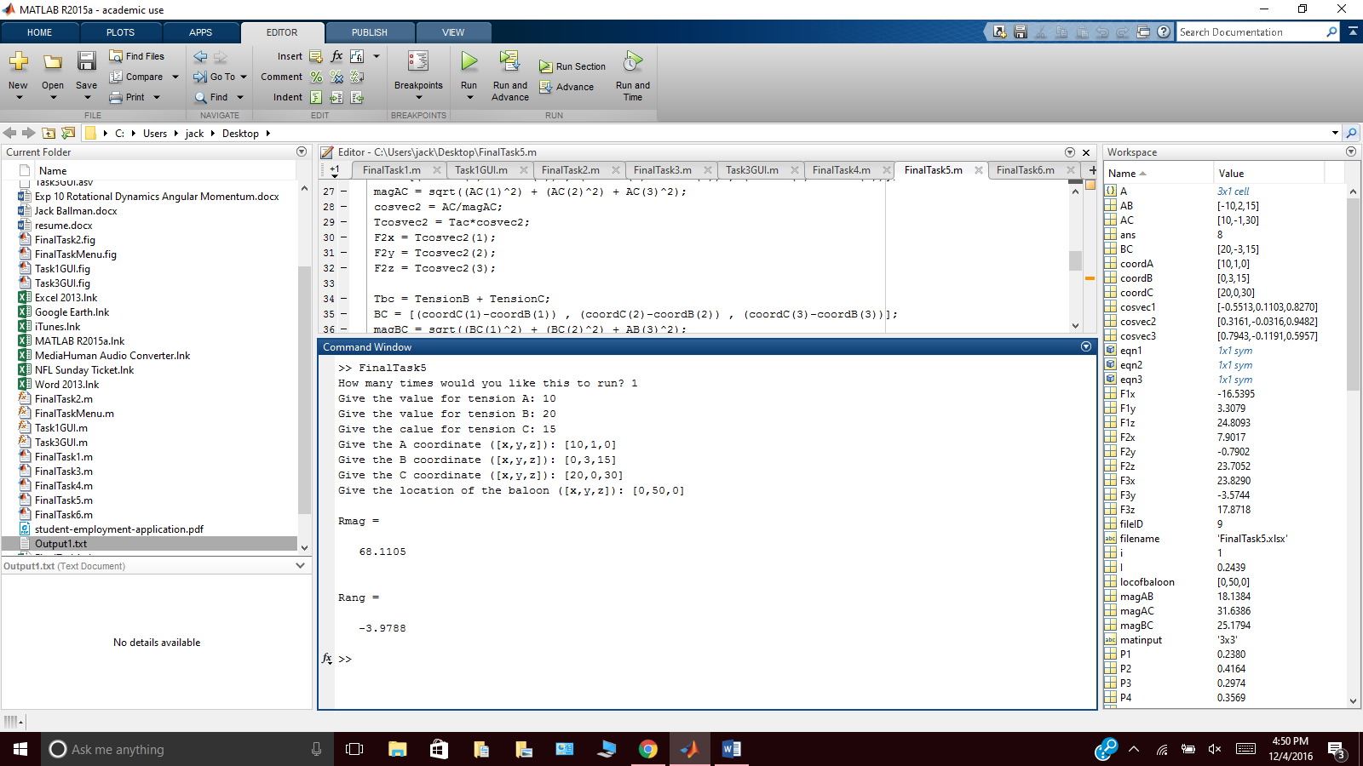

**Task 6**

